Type Casting

1. **When typecasting, are we creating a new object**?
   1. No  
      Strictly speaking through typecasting, we are not creating any new object. For the existing object, we are providing another type of reference variable. That’s we are performing typecasting but not object casting.  
      
2. **When typecasting, what is happening internally?**
   1. Internally new reference variables are being created.   
      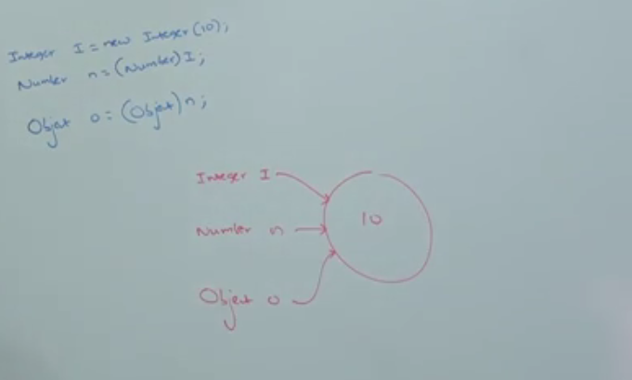

These are new reference variables

1. **How to combine the above statements?**
   1. 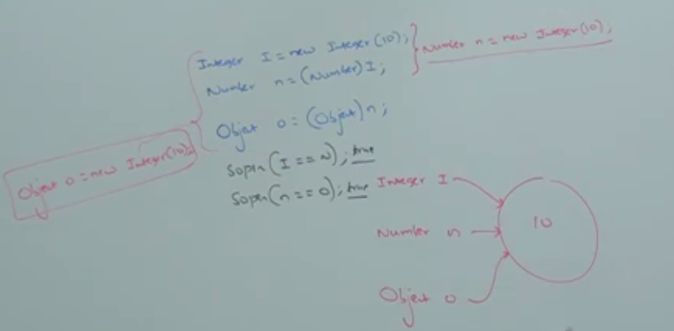
2. 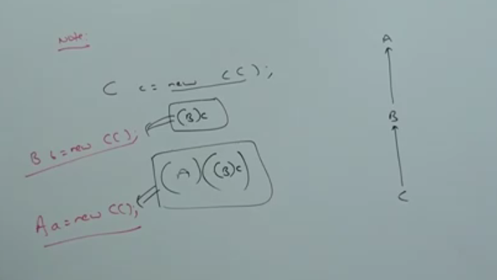  
   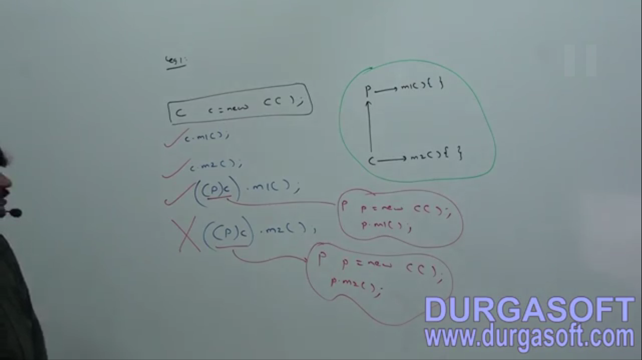  
   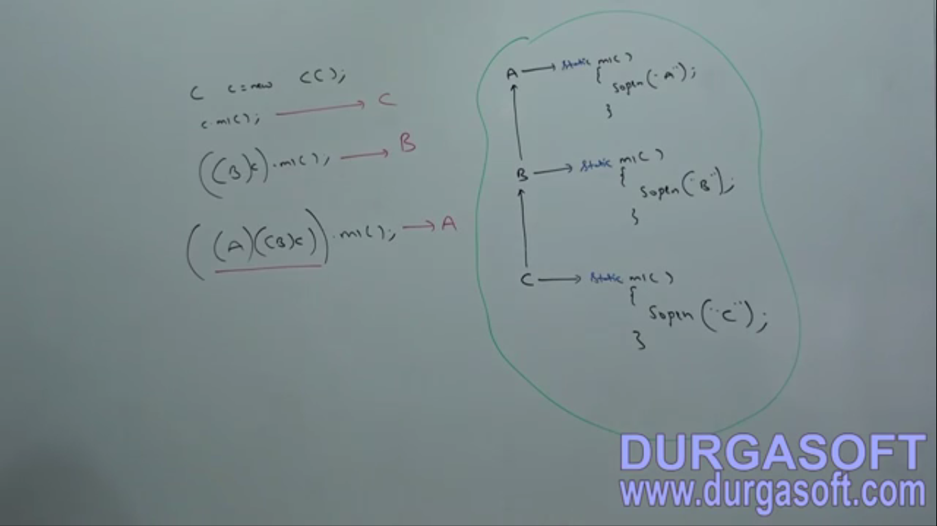

**NOTE**: I found nothing special in here.

It’s Method hiding and method resolution are always based on “**Reference Type**”.

1. 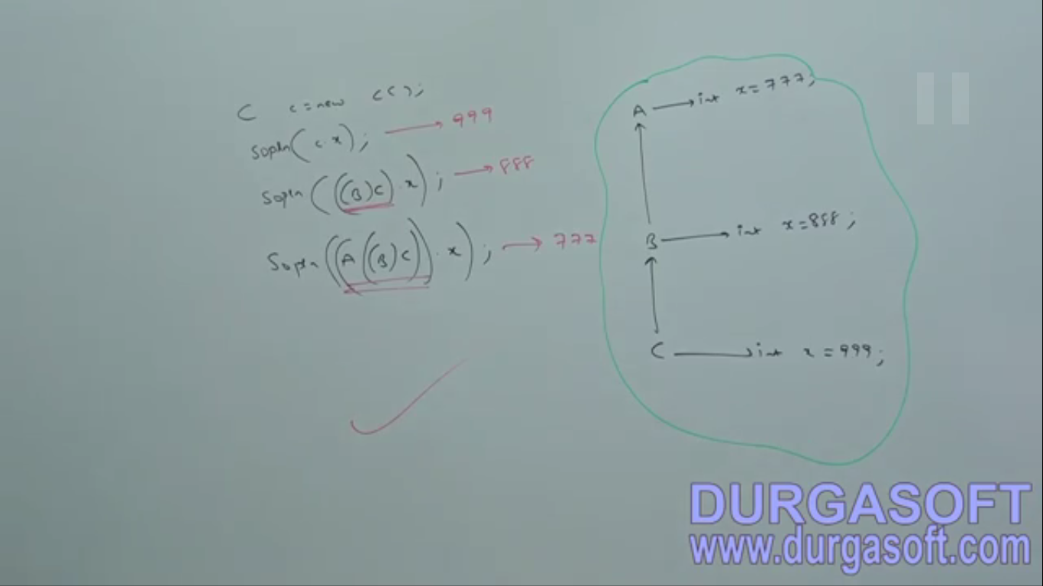

Variable resolution is based on reference type no matter it is static or non static.